Overview

This module is designed to:

1. Teach participants how to plan developmentally-appropriate activities for a group of children based on their ages and individual needs, and
2. Describe the role of caregivers in guiding and directing the child’s learning process both indoors and out.

Student outcomes

|  |  |  |  |
| --- | --- | --- | --- |
| **Student Outcome** | **Washington State Core Competency** | **Corresponding WAC** | |
| **Centers** | **FHCC** |
| **Outcome A**  The student will describe environments which nurture children and stimulate learning. | *Content Area II: Curriculum and Learning Environment*  1b. Follows a consistent yet flexible schedule that is appropriate for all children.  1d. Maintains a physically and emotionally safe environment and creates learning spaces with focus on safety, health, routines and play/exploration.  Content Area I: *Child Growth and Development*  1f. Recognizes that children learn and develop through play. | WAC 170-295-2120  WAC 170-295-5020  WAC 170-295-5040 | WAC 170-296A-4225  WAC 170-296A-4925  WAC 170-296A-6575 |
| **Outcome B**  The student will identify indoor and outdoor activities that invite participation of all children. | *Content Area II:*  1c. Plans regular daily activities that include indoor and outdoor activities.  1f. Offers children choices. | WAC 170-295-2130  WAC 170-295-2120 | WAC 170-296A-5025 |
| **Outcome C**  The student will plan developmentally appropriate activities for children in a variety of settings. | *Content Area II:*  1g. Supports and encourages children’s participation in a variety of activities.  1h. Plans individual, small and large group activities.  1i. Provides a variety of activities that are at the different developmental levels of the children in a setting. | WAC 170-295-2010 | WAC 170-296A-6550  WAC 170-296A-6600 |

🕮 **Required Reading**

1. *Child Care Center Licensing Guidebook* (2nd ed., DEL 2006)   
   **Outcomes A, B and C**: Section 3, pp 41-47 (“What types of play materials, equipment and activities must I provide for the children?”), pp 111-116 (“Are there special program requirements for infants and toddlers?”), pp 180-181 (“How do I maintain a safe environment?”), page 194-197 (“How do I maintain a clean and sanitized environment?”), and pp 116-121 (“Do I need an outdoor play area?”)  
   Online at: <http://www.del.wa.gov/publications/licensing/docs/ChildCareCenterLicensingGuide.pdf>.
2. *Washington State Family Home Child Care Licensing Guide* (2nd ed., DEL, 2013)   
   Section 3, “Care and Education of Young Children” (pages__) and Section 4, “Environments.”

📹 **Videos supporting this Module**

1. A three minute video clip that addresses managing the flow of activity and environment in early education classrooms can be found here: <http://www.youtube.com/watch?v=ib-WgzoO528>
2. A five minute video clip that demonstrates how high quality, nurturing environments can inspire playful learning can be found here: <http://www.youtube.com/watch?v=9xCCBIvgWQ0&feature=relmfu>
3. A brief video clip that illustrates the importance of routine in early learning settings can be found here: <http://www.youtube.com/watch?v=cu9BgsT90-Q&playnext=1&list=PLzZv5VL2z8sPMkSxya8hpMmt8zw5rxeCj&feature=results_main>
4. A brief video with a concise overview of developmentally appropriate classrooms can be found here: <http://www.youtube.com/watch?v=a-h4IHIqkcc>

***Note to Instructors: A student pre-assessment is available at the end of each module, on the first page of handouts.***

[](javascript:edit(232327)) **Opening activity**

This activity can be done at the start of class to get participants thinking about environments and early learning settings. To begin, ask participants to think for a few minutes about a place where they feel particularly welcome and inspired—a place with a particularly pleasing environment. It could be their favorite relative’s home, a favorite restaurant, a beautiful outdoor spot, or a theme park…it’s up to them! Have students think about all the elements that make this place so special. After a few minutes, brainstorm together as a large group the factors that helped them to decide. What made them feel so comforted, inspired and/or welcomed? You might hear themes such as:

* The atmosphere is warm and inviting.
* It offers a feast for the senses / the air is fresh / or the food is incredible!
* I feel comforted and secure.
* People there are friendly and accommodating.
* I always have a good time there.

**Quality early learning environments**

**Quality early learning environments should invoke the same feelings as your favorite place:**

* **We want children and families to enter a warm and inviting environment where their needs are met,**
* **The staff is friendly**
* **It appeals to the sense**
* **Respects each person’s uniqueness**

**Outcome A**

*The student will describe environments which nurture children and stimulate learning.*

🗫 **Discussion Questions**

1. What are the components that make a good early learning environment?
2. What is needed in a good outdoor environment?

👂 **Presentation**

**A child-centered environment consists of several elements:**

* **Staff working closely with children, observing them carefully, and following their lead when possible**
* **Stimulating, challenging activities available throughout the day**
* **Program scheduling, physical layout, and procedures that are best for the children in that space**
* **Children choosing activities**

**These elements must be offered in a safe environment, one free of hazards both inside and out.**

Explain: Refer to the guidebooks for specifics on keeping children safe from harm. In general a safe center is one that is organized with the children’s care and development in mind. It has spaces both indoors and out where children can move and play away from potentially dangerous or hazardous substances. The more carefully you plan the environment, the fewer times adults have to interfere with the children’s self-initiated activity.

**Points to consider when designing curriculum and environments in your center or home:**

* **Providers need to plan for individual differences when scheduling activities for groups of children.**
* **Each child is on his/her own timetable for growth and development. Each reflects her own temperament, learning style, experiences, and family background.**
* **What may be a risky temptation for one child may never even be notice by another child.**

**Additionally, children have learning preferences, just like adults. Some examples of learning differences are:**

* **Some children learn well by listening while others need to do something or practice before they understand fully.**
* **Some children can sit still for longer periods of time. Others need to be free to move about.**
* **Some children want to be able to do an activity perfectly before sharing their accomplishment. Others are more comfortable with trial and error.**
* **Some children are very outgoing and outspoken with adults. Others are uncomfortable when an adult is speaking to them or watching them.**
* **Some children do not like begin told what to do. Others need to hear exactly what is expected of them.**
* **Some children play comfortable in a group. Others prefer to play alone.**
* **Some children cannot wait to crawl into your lap. Others are uncomfortable with being touched.**

**Providers should also be aware that:**

* **The developmental range in the same-age group may be two years or more.**
* **Individual children may have unique interests or skills outside the age range of the group.**
* **Children with special needs may require certain activities to be modified.**

Explain: A well-planned environment encourages children to play and grow socially, emotionally, physically and intellectually. In order to stimulate development in all areas, space should be planned with well-defined interest centers. Interest centers are areas where materials are organized by type, and are accessible to children when they are interested in participating in particular kinds of play. Using these interest areas, children are able to move around the room, make choices, and learn new things. One child may choose a quiet spot to be alone while another might choose a more active area to work with other children. When children change interest areas, they encounter new problems to solve, new children to talk to and work with, and new materials to master in their own way.

**Examples of some of the interest centers that could be included in an early learning space include:**

* **Blocks**
* **Creative art**
* **Music**
* **Dramatic play**
* **Sensory exploration**
* **Library/quiet area**
* **Literacy/writing**
* **Table toys/manipulatives**
* **Science**
* **Computer**
* **Woodworking/building area**
* **Outdoor/large muscle areas**

**Distribute Handout A-1 “Classroom Interest Areas,”** whichcontains a comprehensive list of specific materials that can be included in each of the areas as well as the skills children may learn while playing in those areas.

Although it sounds silly, sometimes a periodic crawl around the environment will give you a sense of what the environment looks like to children. Ask yourself: Is it colorful? Is there a variety of textures? Are things displayed at an appropriate level? Is furniture the right size? Is it pleasing to the parents and staff as well as the children in care? Are there enough materials for children to use in their daily work and can they access the materials independently?

[](javascript:edit(18748)) **Interactive Learning Activities**

**Option 1: Looking at safe, appropriate environments**

**Materials and Resources Needed**

* **Handouts A-2 “Environments” and A-3 “Looking at safe, appropriate environments”**

Using the photos found on **Handout A-2,** have students answer the question on **Handout A-3.** Discuss in small groups or pairs the following:

1. Which age group do you think this environment serves?
2. What five elements about the environment do you find most appealing to that specific age group?
3. What would you change if this were your classroom or home? Why?
4. How many interest areas or learning centers do you see in the photo?
5. Do you believe the environment is inviting *and* safe based on the picture? Explain.

**Option 2: Will it help or will it hurt?**

**Materials and Resources Needed**

* **Handouts A-4, “Will It Help or Will It Hurt?” and A-5 “Will it Help or Hurt worksheet”**

Reading aloud to the group (or working in pairs reading together), review the scenarios from **Handout A-4.** Distribute the worksheet (**Handout A-5**) for students to complete. Have small groups discuss what five things that might help or hurt a child within each scenario. Debrief as a large group after smaller groups have had a chance to discuss.

**Option 3: Setting children up for success**

**Materials Needed**

* **Handout A-6, “Creating an Environment that Promotes Children’s Positive Behavior”**

Discuss in a large group how the behind-the-scenes work of setting up the environment can eliminate problems and promote positive behavior. Using **Handout_**, have participants read the checklist and discuss. This checklist can also be used to evaluate their current or observed space.

**Outcome B**

*The student will identify indoor and outdoor activities that invite participation of all children.*

🗫 **Discussion Questions**

1. What types of play materials, equipment and activities should you provide for children?
2. What are some of the special requirements for infants and toddlers in an early learning environment?
3. Is it necessary to have a daily schedule and routine for children?

👂 **Presentation**

**Indoor and outdoor spaces**

**Indoor and outdoor spaces need to invite all children to engage in activities and productive play. It is recommended that care providers:**

* **Post a daily schedule of lessons and activities for parent and staff access.**
* **Offer a variety of learning materials (See the *Center Guidebook* for extensive lists).**
* **Consistently** plan **for a wide range of learning experiences through lessons, activities and events.**
* **Keep six months of lesson and activity plans available for licensing inspection.**
* **Maintain** **child-adult ratios during transitions and throughout the day.**
* **Use staff planning time productively to improve the quality of program offerings to children.**

**Outdoor environments are just as critical to children’s development as indoor spaces are.**

**Four components to consider when planning a good outdoor play space include:**

* **The space itself**
* **Supervision in the space**
* **Injury protection and prevention**
* **Site maintenance**

**Outdoor space must have at least 75 square feet per child for the maximum number of children using the outdoor play space at any one time.**

Explain: Programs with limited space may stagger the schedule of children using the outdoor space. Children are very creative, so outdoor toys and structures should be examined knowing that children will often use toys in ways never imagined by the manufacturer.

**The daily schedule**

**The daily schedule can ensure a balance of activities throughout the children’s day.**

1. **Young children cannot tell time, but they can learn the time of day by the sequence of activities and routines set in place by caregivers.**
2. **Routines and daily rituals provide a sense of security. Children can predict what happens next.**
3. **Appropriate routines meet the developmental needs and abilities of the children.**
4. **Caregivers discover that routines help children gain a sense of their own identity and self-worth.**

A balance of large group, small group, individual, child-initiated and staff-initiated activities is very important. For younger children, most of these activities should be child-initiated in individual or small groups. Children under age 6 should not spend large amounts of time in staff-initiated, large group activities.

[](javascript:edit(18748)) **Interactive Learning Activities**

**Option 1: Setting up an appropriate daily schedule**

**Materials and Resources Needed**

* **Handout B-1 “Setting up an Appropriate Daily Schedule”**
* Paper and pens
* Copies of the *Child Care Center Licensing Guidebook* or the *Family Home Child Care Licensing Guide*

Begin the activity by dividing students into small groups or pairs. Give each group an age range to plan for: infants, toddlers, or preschoolers. Distribute copies of **Handout .** Ask each group to design their own daily schedule based on what they have already learned about child development and safe environments.

After students have had a chance to complete **Handout B-1**, take a look at the sample schedule found on page 48 in the *Center Guidebook* and page__ in the *Family Home Guide*. Students can check to see where there are matches between their draft daily schedule and the sample provided. Discuss as a large group.

**Option 2: Inside and outside**

**Materials Needed**

* **Handout B-2 “Inside and Outside”**
* Paper and pens

Distribute **Handout B-2**. In small groups, ask students to brainstorm three activities that children could participate in--either indoors or outdoors--and the materials needed to make sure that the activity is successful and will engage each child. Some examples might include:

* Painting with brushes, spray bottles, sponges, bath scrunchies, or hands
* Music with symbols, shakers, drums and rain sticks
* Sensory play with sand, trucks, shovels, buckets, scoopers, colanders and funnels

**Option 3: How much space is required?**

**Materials and Resources Needed**

* **Handout B-3, “Space Requirements”**
* Copies of the *Child Care Center Licensing Guidebook* or the *Family Home Child Care Licensing Guide*
* Optional: Calculators

Read the WACs that discuss space requirements in both the indoor environments (see page 16 in the *Center Guidebook*, and page__ of the *Family Home Guide*), and outdoor environments (see page 116 of the *Center Guidebook*, and page __ of the *Family Home Guide*).

Working in pairs or small groups, ask students to complete the space requirements on **Handout B-3** (calculators may be necessary).

**Outcome C**

*The student will plan developmentally appropriate activities for children in a variety of settings.*

🗫 **Discussion Questions**

1. What does developmentally appropriate practice mean?
2. How do I determine if an activity or material is developmentally appropriate?
3. How do I write a lesson plan for young children?
4. How can I plan for activities that allow for differences, preferences and abilities?

👂 **Presentation**

**Developmentally Appropriate Practice (DAP)**

**Developmentally appropriate practice supports the belief that all children are unique and progress through predictable ages and stages at their own pace.**

Explain: It is the responsibility of the early learning program to offer an assortment of culturally relevant activities, experiences and materials that are based on developmentally appropriate practice or DAP. Developmentally appropriate practice supports the belief that all children are unique and progress through predictable ages and stages at their own pace. It is the provider’s job to make sure that the activities, materials and experiences are appropriate for each child in your care.

**To engage children in active, meaningful learning it is important that you:**

* **Foster positive self-identity and a sense of emotional well-being.**
* **Develop social skills and knowledge.**
* **Encourage children to think critically, reasons, question and experiment.**
* **Enhance physical development and skills.**
* **Encourage and demonstrate sound health, safety, and nutritional practice.**
* **Encourage creative expression, representation and appreciation for the arts.**
* **Develop a sense of belonging to the natural environment.**
* **Ensure the materials and practices of your program reflect the backgrounds and current practices of the children and families enrolled.**
* **Respect and celebrate cultural diversity.**

Explain: As you have learned in previous modules, each child has unique patterns of timing and growth. You will have children in your care with a range of temperaments, learning styles, experiences and family and cultural backgrounds. Programs adapt for differences among children by providing a variety of materials and activities that support children’s individuality.

**While you will be asked to plan for groups of children, it is also important to think about the individual needs of children.**

**Some things to keep in mind when planning:**

* **The developmental range in your group**
* **The children who have interests or skills *outside* the age range of the group**
* **Children with special needs who require modifications to the activities**
* **The opportunity for children to repeat activities**
* **More small group activities**

**It is also important to consider:**

* **How to store and display materials**
* **What the daily schedule will look like and how to balance the routine**
* **What is necessary to include in lesson plans for children**
* **If the planned activities are better suited for indoor or outdoor environments**

**Meaningful Questions**

**Caregivers can increase children’s language acquisition by asking meaningful questions and adding information to extend children’s learning.**

**Meaningful questions invite children to wonder, and to respond with more than a simple “yes” or “no.”**

**Questions can help them learn to solve problems and think critically about what they are engaged in.**

**Handout _** offers examples of the differences between asking thoughtful questions versus simply giving the child information.

Providers demonstrate knowledge of developmentally appropriate practice by selecting materials that are engaging for the children in their care, and following daily structured routines. “Ultimately, the truest measure of developmentally appropriate practice is seeing children joyfully, physically, and intellectually engaged in meaningful learning about their world and everyone and everything in it.” (Copple & Bredekamp, 2009).

[](javascript:edit(18748)) **Interactive Learning Activities**

**Option 1: Selecting appropriate classroom materials**

**Materials Needed**

* **Handout C-1 “Selecting appropriate classroom materials”**
* Catalogs or magazines from leading early learning supply companies

Separate the students into small groups or pairs and give each group an age range to focus on (infants, toddlers or preschoolers). Give students a copy of **Handout C-1.** Using magazines from early childhood supply companies such as Discount School Supplies or Lakeshore Learning, have groups find ten pictures of learning materials that they feel are most appropriate for their age group. If time allows, students can share their collage of pictures and discuss with the large group why they feel that material is age appropriate. Another option is to give specific budgets and request that the students stay within the budget limitations.

**Option 2: What do they learn from that?**

**Materials Needed**

* Toys such as texture balls, small puzzles, Play-doh with tools, small plastic animals, measuring cups and spoons, dolls, etc.
* **Handout C-2 “What do they learn from that?”**

Distribute a random assortment of objects/toys to pairs or small groups of students, along with **Handout C-2**. Try to choose toys that span a variety of age groups. More examples: sorting objects such as small bears or dinosaurs, lacing cards, shape sorters, rattles, ABC magnets and magnetic boards, felt boards, puppets or persona dolls, musical instruments.

In small groups or pairs, make a chart of the developmental skills a child might learn and/or exercise as they play with the object you were given. Think about the domains of development as well as very specific skills (such as physical domain—small or fine muscle movement).

**Option 3: Writing effective weekly schedules**

**Materials Needed**

* Copies of the *Child Care Center Licensing Guidebook* or the *Family Home Licensing Guide*
* **Handout C-3 “Writing Effective Weekly Schedules”**

Students have already had practice in Outcome B with effective daily schedules. Now it’s time to bring them all together in a weekly schedule.

Have students complete **Handout C-3**. Begin this activity by looking at the preschool and the toddler activity plans in the *Center Guidebook* on pages 50-51, and in the *Family Home Guide*, Section 3, pages__. Discuss with the students the similarities and differences between the two plans, focusing on age appropriateness of the activities listed as well as the need for routine. It is also helpful to remind students that it is a licensing requirement to post weekly schedule for staff and parents.

Working in pairs or small groups, ask students to create a mock weekly schedule for either toddlers or preschoolers. If time allows, share the schedules with the larger group.

**Option 4: Asking meaningful questions**

**Materials Needed**

* **Handout C-4, “Asking meaningful questions vs. giving simple information”**

Read **Handout C-4** individually or as a group. In small groups, discuss the difference between asking questions and giving information. If time allows, participants may want to discuss their own situations in which they have extended the child’s learning by asking meaningful questions.

**Option 5: Childcare center design project**

**Materials and Resources Needed**

* Printer Paper or art/drawing paper
* Markers or pens
* Copies of the *Child Care Licensing Guidebook (2nd ed)* or the *Family Home Child Care Licensing Guidebook (2nd ed)*
* *Catalogs or magazines from leading early learning supply companies*
* **Handouts C-5 “Childcare Center Design Project, C-6 “Childcare Center Design Planning Sheet”, C-7 “Childcare Center Design Budget Sheet” and C-8 “Childcare Center Design Rubric”**
* Optional: internet

Students will work individually to design their own childcare center. Distribute copies of **Handouts C-5 (Childcare Center Design Project) and** **C-8 (rubric)** to outline steps of the design project, and what students will be graded on. Read through the directions.

The first step in the project is **Handout C-6, the planning sheet.** Have students begin their planning of their center by deciding the age of students they will be serving and how many children they will be serving based on 1 or 2 staff members. The more children they serve—the more supplies they will need to buy in some cases, such as sleeping mats. Have students decide on a philosophy or mission statement. This can be done by looking at the information in Module 9 for Outcome A on mission statements, or by having students look at their school’s own mission statement, for example. They will then write goals on how they are going to achieve their mission. Lastly, students will decide what learning centers they will include in their center.

On a separate sheet of paper (it can be lined notebook paper), student will start to design a floor plan or layout rough draft of what their center would look like. They will decide where the different learning centers will be located in the room, bathrooms, kitchen, etc. After their rough draft is satisfactory, give the students either blank printer paper or art paper to complete a final floor plan draft.

Next, students will create learning and culture lists for each of their learning centers. This will help them decide what materials to purchase for each learning center. Students should come up with at least two (2) ways to incorporate culture into each learning center, and 10 things children will learn in each of the learning centers. The learning lists should focus on all areas of development—physical, intellectual, emotional and social.

Lastly students will use catalogs or the internet to choose age-appropriate learning materials for their childcare center. Students will need to purchase furniture and supplies, as well as specific materials for each learning center. They should track their purchases on **Handout C-7 (budget worksheet)**, and should stay within the budgeted amount. You can reduce the budget amount, if you would like to make the project more challenging.

**Option 6: Lesson planning project : Teaching young children**

**Materials and Resources Needed**

* Copies of the *Child Care Licensing Guidebook (2nd ed)* or the *Family Home Child Care Licensing Guidebook (2nd ed)*
* *Early Learning Lesson Plan/Curriculum books*
* **Handouts C-9 “Teaching Children Lesson Planning”, C-10 “Teaching Children Lesson Planning Guide”, C-11 “Teaching Children Lesson Plan Scenarios”, and C-12 “Teaching Children Lesson Plan Rubric”**
* Optional: internet access

Divide the students into groups of 3-4 each. Hand each group a copy of **Handouts C-9, C-10, and C-12 (lesson planning, guide, and scenarios)**. Explain that students will be planning and teaching an age-appropriate lesson, as a group, based on a given scenario. Students will plan as a group, and present to the class as an audience. Read through the rubric on **Handout C-12** to help students understand the expectations of the project. Cut the scenarios from **Handout C-11** into strips, and give each group a scenario. Have students start with **Handout C-9 (lesson planning)**, and progress through the steps outlined on that sheet. **Handout C-10 (lesson guide)** follows the same process, and allows them to write their planning steps in the packet.

Students will be assigning roles to their group members to facilitate cooperative work in the project. Next students will brainstorm ideas of possible lesson ideas based on their scenario. Students can use Early Learning Lesson Plan/Curriculum books or the internet to search for activity ideas. They need to make sure the activity is age-appropriate and matches the expectation of the theme and type of activity. Students will narrow down their ideas until they have arrived at a group decision on the best activity for their scenario. Next students will be writing a complete lesson plan to prepare for teaching the activity to their audience. They will also complete a time plan, to know exactly how long their lesson will take with set-up, teaching and clean-up.

Lastly, Students will teach the lesson to the class and complete a written summary of how their lesson improves learning and skill development in children.

**🗹 Assessment of Learning**

Have students take the quiz, **“Check for Understanding.”**

**Student Pre-assessment**

Name Per Date

1. List two elements of a “child-centered” environment:

1)

2)

1. Identify three different types of interest/learning centers that are commonly found in Early Childhood classrooms:

1)

2)

3)

1. True or False? Washington State has strict licensing laws regarding how much indoor and outdoor space is required for safe and healthy environments.

1. Explain why children need a daily routine in the classroom:

1. Define “developmentally appropriate practice”:

**Handout A-1**

Classroom Interest Areas (Centers)

The materials listed in the chart below are in no way a complete or required list of materials for every early learning environment.

|  |  |  |
| --- | --- | --- |
| **Center** | **In play in this center, children learn** | **Materials that should be available** |
| Block | -shapes and sizes  -problem solving  -cooperation  -imaginative play  -basic number concepts  -creativity  -how to lift and carry blocks | -wooden unit blocks stored in open low shelves by size and shape  -play props such as play figures representing diverse populations  -farm, forest, and jungle animals  -cars, trucks, and boats  -raw building materials such as branches, canvas, corn husks, etc. |
| Creative art | -to express their ideas and feelings  -develop fine motor skills  -learn creativity  -learn exploration  -discover that we all have different ideas and different ways of working | -easels  -paint containers  -a wide variety of different sized and shaped brushes  -people color and regular color crayons  -scissors  -markers  -glue  -modeling clay  -hand mirrors  -play-doh  -collage materials  -a wide variety of size and types of paper  -a paint drying rack or area |
| Dramatic play | -learn to act out familiar adult roles  -learn to conquer fears such as going to the doctor  -develop social skills such as sharing, cooperation, compromise, and negotiation  -develop fine motor skills  -learn respect for differences in people and cultures  -role play people of other cultures, abilities and genders | -child-size furniture and equipment such as table and chairs, stove, refrigerator, and sink  -male and female work and play clothes  -cooking and eating utensils like those found in children’s homes  -male and female dolls representing a diversity of races, cultures, and abilities  -play food representing different cultures |
| Sensory exploration | -size, shape and volume  -creativity  -releasing tension  -control  -discovery  -exploration | -a low to the floor dry sensory table to use with various materials  -a waist high wet sensory table to use with water, bubbles, cornstarch and water, ice/snow, shaving cream, whipped soap flakes  -tools and objects to sink and float |
| Library/quiet area | -the “mechanics” of holding and enjoying books  -reading with others  -awareness of print  -how to spend quiet time alone  -listening to books on tape  -develop fine motor skills  -pictures have meaning  -tell stories using puppets or flannel boards  -develop pre-reading skills  -learn about diversity and other cultures  -learn facts and information outside of their personal experience | -book display  -rug  -soft pillows, cushions or upholstered chairs/couch  -tape recorder  -homemade books featuring the children and families in your center  -wide variety of books that depict cultural diversity  -puppets |
| Literacy/writing | -awareness of letters  -develop fine motor skills  -learn new words and meanings  -practice holding smaller writing instruments | -clipboards  -writing instruments including markers, chalk, crayons, pencils  -pencil grips  -small white boards with erasers  -small chalk boards  -mailboxes  -paper/stationery  -stickers/stamps |
| Table toys/manipulatives | -pre-reading and pre-math concepts  -eye hand coordination  -fine motor skills  -problem solving  -categorization, grouping, patterns  -develop creativity | -items on low shelves  -puzzles and toys that represent cultural diversity  -table with chairs  -pegs and pegboards  -beads and laces  -parquetry blocks  -collections of items for sorting, classifying and counting  -nesting rings/cups  -bristle blocks  -sewing cards  -matching games |
| Science | -discovery of natural objects  -magnetic forces  -bigger/smaller through magnifying objects  -cause and effect in the environment  -life cycles of butterflies, frogs  -colors | -magnifying glass  -scale  -droppers and tweezers  -specimen jars  -natural objects such as shells, rocks, nests, beehives, cocoons, leaves  -bug catchers  -bottles with colored waters  -color paddles  -light box |
| Computer | -basic computer skills like power, mouse manipulation  -one/two step directions  -fine motor skills  -simple keyboarding skills | -computer  -mouse  -paper  -approved educational software  -keyboard |
| Woodworking area | -how items fit together  -how to make simple structures  -problem solving  -durability of materials and objects  -handling of tools safely  -safety | -wood  -nails  -different types of hammers  -eye glasses  -gloves  -screws  -pegboards  -work lights held up with clips |
| Outdoor/large muscle areas | -large and small motor skills  -eye hand coordination  -confidence  -sharing, taking turns, and cooperative play  -sensory experiences  -dramatic play | -safe climbing toy  -area for digging  -shovels  -pails  -trucks  -riding toys with helmets  -wagons  -balls  -hoops  -tunnels  -parachute  -games  -natural materials such as rocks, leaves, sticks |

**Handout A-2**

**Environments**

**Picture 1**

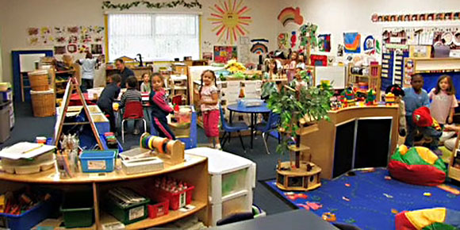

Credit: NAEYC.org

**Picture 2**

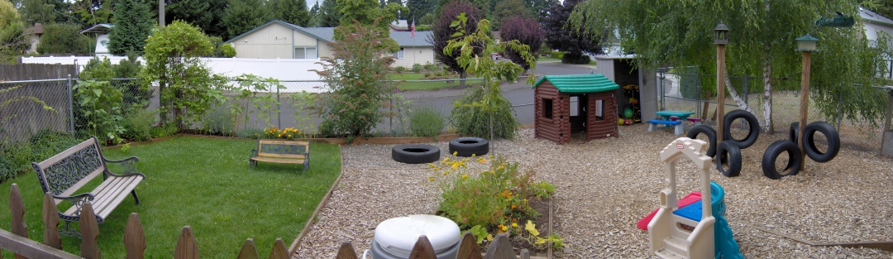

Credit: Vancouver Montessori

**Picture 3**

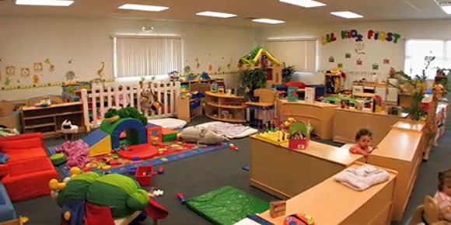

Credit: Allkidsfirstnj.com

**Picture 4**

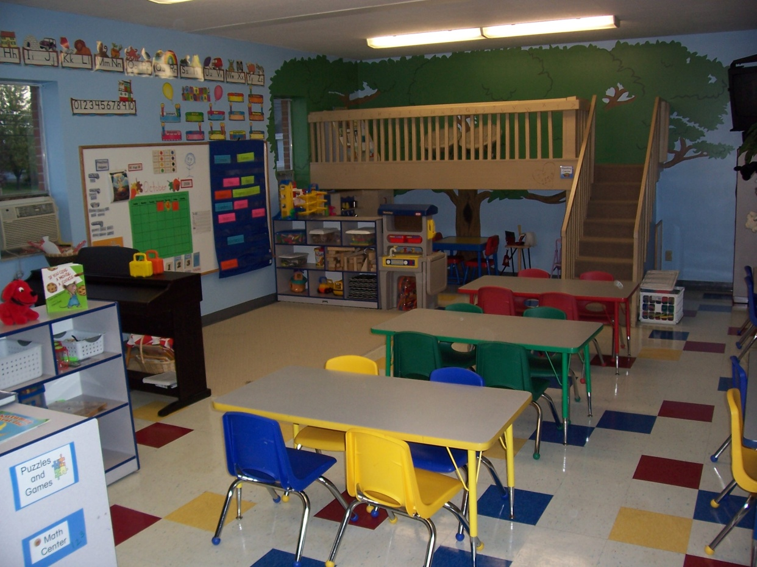

Credit: beautifulsavior-gc.net

**Picture 5**

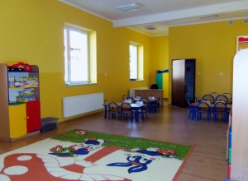

Source: teachthemdiligently.net

**Picture 6**

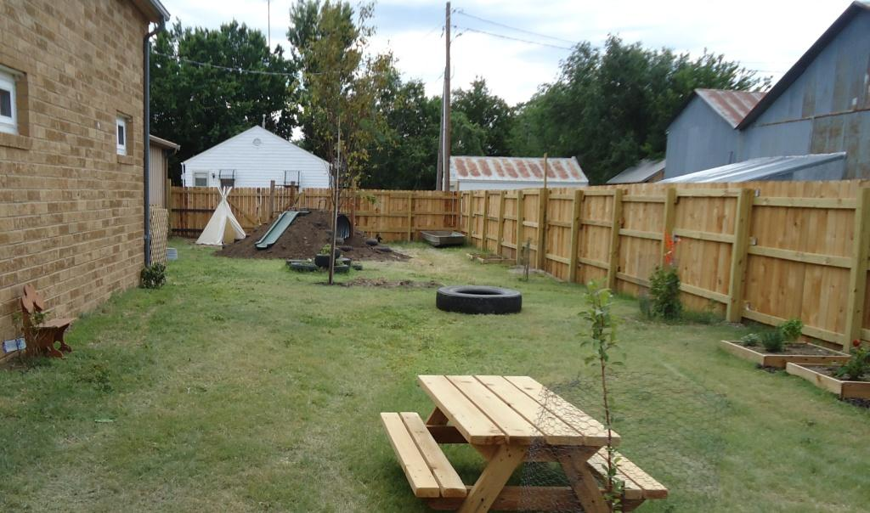

Credit: childcarecenter.us

**Picture 7**

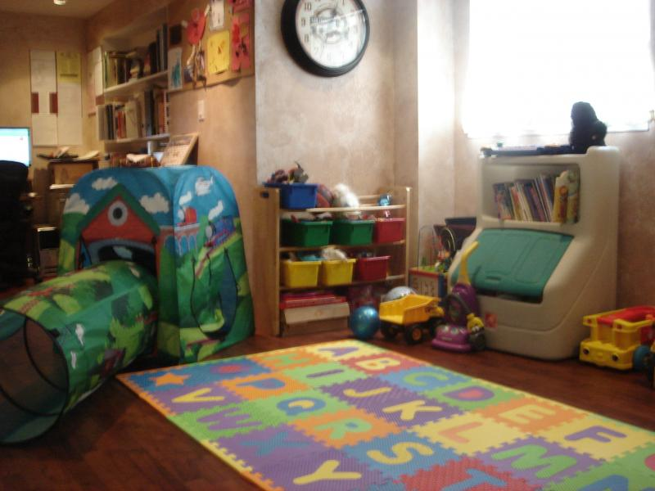

Source: Small Wonders Family Child Care

**Picture 8**

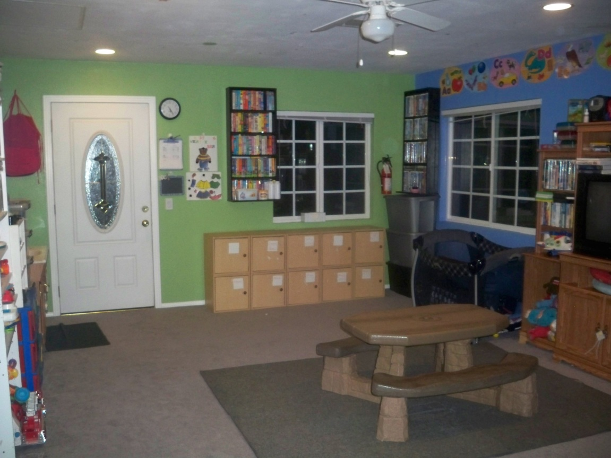

Source: Harris Family Child Care

**Handout A-3**

Looking at Safe, Appropriate Environments

Name______________________________________________Per______Date____________

**Using the photos on Handout_, answer the following questions:**

**Picture #_________**

1. Which age group do you think this environment serves?
2. What five elements about the environment do you find most appealing to that specific age group?
3. What would you change if this were your classroom or childcare center? Why?
4. How many interest areas or leaning centers do you see in the photo?
5. Do you believe the environment is inviting *and* safe, based on the picture? Explain.

**Picture #_________**

1. Which age group do you think this environment serves?
2. What five elements about the environment do you find most appealing to that specific age group?
3. What would you change if this were your classroom or childcare center? Why?
4. How many interest areas or leaning centers do you see in the photo?
5. Do you believe the environment is inviting *and* safe, based on the picture? Explain.

Looking at Safe, Appropriate Environments, cont.

**Picture #_________**

1. Which age group do you think this environment serves?
2. What five elements about the environment do you find most appealing to that specific age group?
3. What would you change if this were your classroom or childcare center? Why?
4. How many interest areas or leaning centers do you see in the photo?
5. Do you believe the environment is inviting *and* safe, based on the picture? Explain.

**Picture #_________**

1. Which age group do you think this environment serves?
2. What five elements about the environment do you find most appealing to that specific age group?
3. What would you change if this were your classroom or childcare center? Why?
4. How many interest areas or leaning centers do you see in the photo?
5. Do you believe the environment is inviting *and* safe, based on the picture? Explain.

**Handout A-4**

**Will It Help or Will It Hurt?**

Scenario #1

The pre-kindergarten room has 20 children, a lead teacher, and a teacher assistant. Some children are playing quietly, while others race around playing superheroes, using the brooms from the housekeeping area as guns. A demolished block building is in the middle of the floor. Other children are enthusiastically looking at the bird nest that one child brought in this morning, and finding books about birds from the book corner. A snack of vanilla pudding with bananas was delivered an hour ago from the kitchen and is sitting on the counter next to the bird nest, waiting to be served. Pictures are hung at the children’s eye level. A brightly decorate bulletin board displays their art work and color pictures from an animal ABC book.

Scenario #2

The toddler room has 14 children, a lead teacher, and one part time assistant who works four hours a day. During most days, the children spend 20 minutes outside, but if it is raining, or warm, the teacher prefers to extend play time and does not take the children outdoors. The children will nap if they are in the mood after they have had a mid-afternoon snack. In the morning upon arrival, the assistant makes certain to have loud reggae music playing to wake them up. Some days, story time will last 30 minutes and other days the teacher forgets to read to the children after waking up.

Scenario #3

The infant room at the center has 6 children with two lead teachers. When you arrive to observe, two of the infants are in swings, one is propped up in an infant chair with a propped bottle. The two infants are rolling on the ground, sucking on toys and passing them back and forth between each other. One teacher is changing a diaper and the other is busy making a bottle for the crying child in one of the swings to stick in the microwave.

Scenario #4

The preschool room at your child’s program has 20 children enrolled with two teachers and an assistant who help at meal time. Children are coming in from outside play activities 10 at a time and are taking off jackets to wash their hands at the sink. After washing, they pick up a plate, spoon and fork asking what is for lunch. They sit at the tables in groups of 6 or 7 with a teacher and pass the food around family style. While eating, the teachers talk to the children about what they are eating and how it nourishes their bodies.

Scenario #5

At Happy Bees Family Child Care Center, Michelle has 6 children enrolled ages 6 months through 4 years old. Michelle has separated part of the space in her large classroom to accommodate the two infants in her care by using a large portable baby gate that she can clearly see over and through. While she is holding an infant, she enjoys reading a book to 3- year old Aidan who is sitting in her lap just inside the baby gate.

**Handout A-5**

**Will it Help or Will it Hurt?**

**Worksheet**

Name______________________________________________Per______Date____________

**In each scenario, identify 5 things that may help or hurt child development within each scenario.**

1. Scenario 1:

2. Scenario 2:

3. Scenario 3:

4. Scenario 4:

5. Scenario 5:

**Handout A-6**

Creating an Environment that Promotes Children’s Positive Behavior

Name______________________________________________Per______Date____________

Much of managing children’s behaviors in the classroom is from the behind-the-scenes work that a caregiver does before the children arrive to create an environment that promotes positive behavior. What is placed in an area and how it is arranged often determines the atmosphere for promoting social, emotional, intellectual and physical growth. It also determines the behaviors, both positive and negative, that happen in that space.

The following checklist can help you create an environment that promotes children’s positive behavior in your center.

|  |  |
| --- | --- |
|  | The classroom has a variety of learning and activity centers to encourage choice and independence. |
|  | Age-appropriate materials and toys are displayed on low, open shelves allowing children to get the toys and put them away by themselves. |
|  | There are enough materials and toys available so that children can choose what they want to play with and have the ability to play with them for long periods of time. This will decrease children’s fight over toys. |
|  | Learning and activity centers are set up for several children (up to 4 or 5) to play together. This allows them to cooperate, share and problem solve together. |
|  | A large space for whole group activities is provided to allow for group activities, discussion, and problem solving. |
|  | There are small, quiet, private areas (within adult supervision) so that children can be alone or play with just one or two other children. |
|  | The room is un-crowded and has space for children to work and play at the tables. And on the floor. Congestion is avoided and children can move about and explore. |
|  | Centers and activity areas are well defined and placed so activities are not interrupted. Children know what not do in each area. Toys are in bins that are clearly labeled. |
|  | Low dividers are used to separate areas so that caregivers can easily observe the children and supervise their activities. |
|  | Individual cubbies are available so that children can be responsible for their own belongings. |
|  | Placement of furniture discourages rough play or running. |

Modify the environment throughout the day to meet the emerging needs of children in your care. You can add props to the dramatic play or playground areas to promote social interaction or broaden play that is already in progress. Modifying the environment is the first step in helping children to behave appropriately.

Source: *Child Care Center Licensing Guidebook*

**Handout B-1**

Setting up an Appropriate Daily Schedule

Name______________________________________________Per______Date____________

Directions: You are tasked with creating a daily schedule for Preschool classroom. Match the activities with what you believe is the appropriate time for the activity for this age group.

**Time Schedule Activity**

|  |  |
| --- | --- |
| _____7:00-8:00 am  _____8:00-9:00 am  _____9:00-9:30 am  _____9:30-9:45 am  _____9:45-9:50 am  _____9:50-10:50 am  _____10:50-11:45 am  _____11:45-12:15 pm  _____12:15-12:30 pm  _____12:30-1:30 pm  _____1:30-3:00 pm  _____3:00-3:15 pm  _____3:15-3:30 pm  _____3:30-4:30 pm  _____4:30-5:30 pm  _____5:30-6:00 pm | a. Quiet Time or Nap Period  b. Circle Time  c. Snacks  d. Childcare opens, breakfast, greetings  e. Lunch  f. Get ready for rest, mats out  g. Group Activities  h. Free time (Activity centers)  i. Snacks  j. Wash up  k. Small and Large Muscle activities  L. Clean up and circle time, Songs, stories  m. Free time (activity centers, coloring, paint)  n. Group activities  o. Childcare closes, farewells  p. Free time (outdoor play) |

1. After looking at the sample schedule in the licensing guidebook, what similarities did you see between the schedule you created, and the sample?

2. What differences did you notice between your schedule and the sample schedule?

Setting up an Appropriate Daily Schedule (KEY)

Name______________________________________________Per______Date____________

Directions: You are tasked with creating a daily schedule for Preschool classroom. Match the activities with what you believe is the appropriate time for the activity for this age group.

**Time Schedule Activity**

|  |  |
| --- | --- |
| ___d__7:00-8:00 am  ___h or m__8:00-9:00 am  ___L__9:00-9:30 am  ___c or i__9:30-9:45 am  ___J__9:45-9:50 am  ___k__9:50-10:50 am  ___g or n__10:50-11:45 am  ___e__11:45-12:15 pm  ___f__12:15-12:30 pm  ___a__12:30-1:30 pm  ___p__1:30-3:00 pm  ___b__3:00-3:15 pm  ___c or i__3:15-3:30 pm  ___g or n__3:30-4:30 pm  ___m__4:30-5:30 pm  ___o__5:30-6:00 pm | a. Quiet Time or Nap Period  b. Circle Time  c. Snacks  d. Childcare opens, breakfast, greetings  e. Lunch  f. Get ready for rest, mats out  g. Group Activities  h. Free time (Activity centers)  i. Snacks  j. Wash up  k. Small and Large Muscle activities  L. Clean up and circle time, Songs, stories  m. Free time (activity centers, coloring, paint)  n. Group activities  o. Childcare closes, farewells  p. Free time (outdoor play) |

1. After looking at the sample schedule in the licensing guidebook, what similarities did you see between the schedule you created, and the sample?

2. What differences did you notice between your schedule and the sample schedule?

**Handout B-2**

**Inside and Outside**

Name______________________________________________Per______Date____________

Directions: Brainstorm 3 activities below, either indoor or outdoor, and include what materials would be needed to make sure that the activity is successful and will engage each child.

1. Activity:__________________________________________

Description of activity:

Indoors _______ or Outdoors _______

Materials needed:

2. Activity:__________________________________________

Description of activity:

Indoors _______ or Outdoors _______

Materials needed:

3. Activity:__________________________________________

Description of activity:

Indoors _______ or Outdoors _______

Materials needed:

**Handout** **B-3**

**Space Requirements**

Name______________________________________________Per______Date____________

How much square footage is necessary for indoor space? __________________

How much square footage is necessary for outdoor space? _________________

|  |  |
| --- | --- |
| **Situation** | **How much space is needed?** |
| 1 classroom  Infants under 12 months  6 enrolled |  |
| 2 classrooms  Toddlers in each room  18 total enrolled  One bathroom between rooms |  |
| 1 classroom  Infants under 12 months  4 enrolled |  |
| Outside playground  Preschoolers  20 enrolled |  |
| 4 classrooms  2 toddlers  2 preschoolers  14 toddlers enrolled  28 preschoolers enrolled |  |
| Outside playground  Toddlers  14 enrolled |  |
| 6 classrooms  1 infant room: 4 enrolled  2 toddler rooms: 14 enrolled  3 preschool rooms: 30 total |  |
| Outside playground  Shared by toddlers  14 enrolled  Preschoolers  14 enrolled |  |
| Family Child Care Home  1 teacher/owner  1 assistant in the afternoon  6 children: 6 months, 1 year, 2 year, 2 year, 3 year and 4 years old. |  |

Space Requirements

**Teacher’s Key**

Name______________________________________________Per______Date____________

How much square footage is necessary for indoor space? __50 ft. per. Infant, 35 ft. for other ages, and also 35 ft. per child in home care_____________

How much square footage is necessary for outdoor space? ____75 sq. feet_______

|  |  |
| --- | --- |
| **Situation** | **How much space is needed?** |
| 1 classroom  Infants under 12 months  6 enrolled | 300 sq. feet indoors |
| 2 classrooms  Toddlers in each room  18 total enrolled  One bathroom between rooms | 630 sq. feet indoors |
| 1 classroom  Infants under 12 months  4 enrolled | 200 sq. feet indoors |
| Outside playground  Preschoolers  20 enrolled | 1,500 sq. feet outdoors |
| 4 classrooms  2 toddlers  2 preschoolers  14 toddlers enrolled  28 preschoolers enrolled | 1,470 sq. feet indoors |
| Outside playground  Toddlers  14 enrolled | 1,050 sq. feet outdoors |
| 6 classrooms  1 infant room: 4 enrolled  2 toddler rooms: 14 enrolled  3 preschool rooms: 30 total | 1,740 sq. feet indoors |
| Outside playground  Shared by toddlers  14 enrolled  Preschoolers  14 enrolled | 2,100 sq. feet outdoors |
| Family Child Care Home  1 teacher/owner  1 assistant in the afternoon  6 children: 6 months, 1 year, 2 year, 2 year, 3 year and 4 years old. | 210 sq. feet |

**Handout C-1**

**Selecting Appropriate Classroom Materials**

Name______________________________________________Per______Date____________

Directions: Find and attach below 10 learning materials that are appropriate learning materials for your age group.

Age Range:_________________________

Budget:____________________________ Total cost:___________________________

Reflection: Why are these materials appropriate for your age range?

**Handout C-2**

**What do they learn from that?**

Name______________________________________________Per______Date____________

Directions: While examining the toys/objects provided, think about what children would learn from playing from the item. List any developmental skills that you believe a child might learn or exercise while they play with the object. Try to find developmental skills in all domains of development—PIES.

|  |  |  |  |  |
| --- | --- | --- | --- | --- |
| **Toy/Object:** | **P**  **Physical** | **I**  **Intellectual** | **E**  **Emotional** | **S**  **Social** |
|  |  |  |  |  |
|  |  |  |  |  |
|  |  |  |  |  |
|  |  |  |  |  |
|  |  |  |  |  |

**Handout C-3**

**Writing Effective Weekly Schedules**

Name______________________________________________Per______Date____________

Directions: Use the Licensing Guidebook, page 50-51, to see sample weekly schedules. Answer the questions below:

1. What are the similarities between the sample schedules?

2. What are the differences between the sample schedules?

3. Are the activities planned age appropriate on each schedule? Why or Why not?

4. How do sample schedules show the importance of routine for children?

5. What is the licensing requirement for posting weekly schedules for parents and staff?

**Use this information to create your own effective weekly schedule for a childcare center.**

**Handout** **C-4**

Asking Meaningful Questions vs. Giving Simple Information

Name______________________________________________Per______Date____________

Caregivers can increase children’s language and vocabulary and extend the child’s learning by asking meaningful questions. This also allows the child to begin to problem solve, think creatively and engage more fully in their environment. The chart below offers examples of thoughtful questions to ask versus simply giving the child information.

|  |  |  |
| --- | --- | --- |
| **Scenario** | **Meaningful Questions** | **Giving Information** |
| A child brings her dog for show and tell to preschool. All of the children are very excited about the dog. | -What does your dog like to do?  -How are dogs the same as/different from people? How about cats?  -How do you take care of your dog? | -All dogs have four legs and are covered with fur.  -Dogs need to be cared for. They need food and water and exercise.  -Doctors who care for animals are called veterinarians. |
| It is late September and you have taken the class for a walk to collect leaves. | -Why do you think that the leaves are different shapes, colors and sizes?  -When do leaves fall off the trees?  -Why do leaves fall off trees? | -Leaves change colors and fall to the ground in fall.  -There are many different kinds of trees. Each tree has its own shape and size of leaf.  -Leaves grow on trees every spring. |
| It is the first snowfall of the year. | -What is the temperature like outside when it snows?  -What are some of the things we can do in the snow?  -What happens to snow when it gets warm? | -All snowflakes are different.  -It must be cold outside to snow.  -Snow melts and changes to water when warm.  -We wear warm coats, hats, mittens, and boots to go outside in the snow. |
| Write a scenario here: | What are three questions you could ask? |  |
| Write a scenario here: | What are three questions you could ask? |  |

**Handout C-5**

Childcare Center Design Project

Name______________________________________________Per______Date____________

Directions: Imagine you are building and opening a new childcare center!

For this project, you will be developing your own floor plan and purchasing play materials for a child-centered, learning-focused, age-appropriate childcare.

Complete the following steps in the childcare design process. At each step, have your instructor approve your work, and initial the space before moving on to the next task.

________1. **Planning Sheet** (childcare center name, ages, philosophy/goals)

________2. **Floor Plan Rough Draft**—Must include a minimum of 6 learning centers within your plan. Reflect on child accessibility, safety, storage, and child needs. Analyze space, and noise in design. Create a rough draft on your own notebook paper.

________3. **Floor Plan Final**—Use craft/design paper from instructor

________4. **Learning List**—Provide a list of 10 things you want children to learn from each learning center (Include all developmental areas—PIES). This should be done with careful consideration to help guide learning material decisions.

________5. **Culture List**—List two ways that you can incorporate the culture of children into each of the different learning centers. You can do this by purchasing learning materials and supplies, or by outlining activities that can be done in this learning center.

________ 6. **Learning Materials**—Include a minimum of 6 learning material items for each learning center. Include cutouts of product from educational supply catalogs or draw into the floor plan. List what area of learning (from list) is addressed by each item.

________7. **Additional Supplies/Materials**—Create a supply list of additional furniture (cubbies, tables, chairs, etc.) necessary for the functioning of your childcare center, based on the age it serves. You may also include any decorative items that you want to add—such as rugs, art, etc.

________8. **Budget**—You have a budget of $6,000. You cannot exceed this total. Create a detailed list of items—including what it is you are buying, from what company, quantity and price on your budget form.

**Handout C-6**

Childcare Center Design Planning Sheet

Name______________________________________________Per______Date____________

1. What age/ages do you want your childcare center to serve?
2. Refer to ratio and staffing information in the Child Care licensing handbook. How many children will your center serve? _________________________________
3. Brainstorm names for your childcare center. List at least 5 possible names. Circle your top choice.

1.

2.

3.

4.

5.

1. Philosophy or Mission Statement and Goals: Brainstorm the type of learning environment you would like to create in your center. Create a philosophy or mission statement. Write at least 5 learning goals for your childcare center that match your philosophy for your learning environment.

1.

2.

3.

4.

5.

1. Floor Plan/Learning Centers: Brainstorm learning centers you would like to include in your childcare. Circle at least 6 centers you would like to include in your center.

1.

2.

3.

4.

5.

6.

**Handout C-7**

Childcare Center Design Budget

|  |  |  |  |
| --- | --- | --- | --- |
| **Quantity** | **Description** | **Price** | **Total** |
|  |  |  |  |
|  |  |  |  |
|  |  |  |  |
|  |  |  |  |
|  |  |  |  |
|  |  |  |  |
|  |  |  |  |
|  |  |  |  |
|  |  |  |  |
|  |  |  |  |
|  |  |  |  |
|  |  |  |  |
|  |  |  |  |
|  |  |  |  |
|  |  |  |  |
|  |  |  |  |
|  |  |  |  |
|  |  |  |  |
|  |  |  |  |
|  |  |  |  |
|  |  |  |  |
|  |  |  |  |
|  |  |  |  |
|  |  |  |  |
|  |  |  |  |
|  |  |  |  |
|  |  |  |  |
|  |  |  |  |
|  |  |  |  |
|  |  |  |  |
|  |  |  |  |

Childcare Center Design Rubric **Handout C-8**

|  |  |  |  |  |
| --- | --- | --- | --- | --- |
| Category | 4 | 3 | 2 | 1 |
| Goals | 5-6 childcare goals, complete sentences, appropriate for age and design | 3-4 childcare goals written mostly appropriate for age and design | 1-3 childcare goals written, some appropriate for age and design | At least one goal written, not appropriate for age or design |
| Floor Plan | Includes all 8 learning centers, Includes functionality, storage, with careful consideration of child access, noise and safety | Includes 6-8 learning centers, Mostly includes functionality, storage, with consideration of child access, noise and safety | Includes a minimum of 4 learning centers, some functionality, storage, with some consideration of child access, noise and safety | Includes 1-3 learning centers, little consideration of functionality, storage, child access, noise and safety |
| Supplies | 5 learning toys/supply items per learning center, appropriate for age, align with center purpose, and engage learning. | 3-4 toys/supply items per learning center, mostly appropriate for age, mostly align with center purpose, and engage learning. | 1-2 learning toys/supply items per learning center, some appropriate for age, some align with center purpose, somewhat engage learning. | 0-1 learning toys/supply items per learning center, not appropriate for age, not aligned with center purpose, and doesn’t engage learning. |
| Budget | Detailed budget sheet, completed quantities, filled out and mathematically correct. Stayed within the allowed budget. | Mostly detailed and complete budget sheet, mostly filled out and math is correct. Stayed within the budget. | Some of budget sheet filled out, mostly correct and detailed, some errors in math. Did not stay within the budget. | Very little of budget sheet filled out, not detailed, mathematically incorrect. Did not stay within budget. |
| Culture | Cultural experiences outlined in detail, at least two per learning center, age appropriate, and inclusive. | 1-2 cultural experiences outlined in detail at each learning center, mostly age appropriate and inclusive. | 1-2 cultural experiences listed, not detailed per learning center. Some age appropriate and inclusive. | 0-1 cultural experiences listed, not detailed, not age appropriate or inclusive. |
| Learning | Learning for each learning center outlined, and described—at least 10 things per center. Learning is age appropriate and reflected by supplies/floor plan. | Learning for each learning center outlined, and described—at least 7-10 things per center. Learning is mostly age appropriate and mostly reflected by supplies/floor plan. | Learning for each learning center is listed—at least 5 things per center. Some learning is age appropriate and reflected by supplies/floor plan. | Learning for each learning center is listed—less than 5 things per center. Learning is not age appropriate and not reflected by supplies/floor plan. |

**Handout C-9**

Teaching Children Lesson Plan

Name______________________________________________Per______Date____________

**Directions:**

As a group you will be planning an activity/lesson for your imaginary childcare classroom. Your group will be taking on the role of the teacher in that classroom. You will receive a scenario that outlines: age group (toddler or preschooler), theme, and type of activity (Mathematics, Science, or Literacy).

Complete each step below. At each step, have your instructor approve your group’s progress, and initial the space below before moving on to the next task.

1. _________**Overview of Project:** Read through the planning packet, and the scenario to gain an understanding of the theme, ages, and type of activity you will be planning. Review your available materials that can be used for planning your lesson.
2. _________**Group Roles:** Assign roles for this project using the group role sheet.
3. _________**Brainstorm ideas**: Complete your brainstorming sheet for a lesson activity that will take about 15 minutes of time, that will be age-appropriate for your classroom, follow the required activity type and will only use the resource materials you have been given.
4. _________**Lesson Plan:** Complete the lesson plan outline completely with step by step instructions written out, like a script; divide up the responsibilities in your group. Include how you will teach or explain the activity at an appropriate age level. This can be typed or hand-written. Everyone must actively participate in the lesson make sure you divide parts evenly.
5. _________**Time-Line:** including set-up and clean up. This can only account for an additional 10 minutes of time—for a total of no more than 25 minutes. Assign each step to a group member, so there is equal work and involvement.
6. _________**Learning Reflection:** Be sure you can show what the children will be learning in your lesson, and how it relates to increasing their development—Physically, Intellectually, Emotionally and Socially. Write at least 1 page summary discussing your lesson, what the child will be learning and exploring during the lesson, how it relates to PIES and why it is an age appropriate lesson.

**Handout C-10**

Teaching Children Lesson Plan Guide

Name______________________________________________Per______Date____________

**Group roles:** Each person in your group will have a specific responsibility to help the group succeed in your assignment task.

* + Read through the roles, and make sure everyone understands the role definitions.
  + Discuss as a group your strengths and weaknesses for each task.
  + Have each member of your group share what role would be their 1st choice, and what role they would prefer not to have.
  + Come to a consensus on the role assignments, and assign roles.

Facilitator: Gets group started, initiates group discussion, and monitors work process, ensuring that everyone listens and speaks respectfully.

Writer/Recorder: Records group’s responses to questions, brainstorming tasks and/or edits what group has written.

Reader/Encourager: Reads the scenario, information and/or instructions to the group. Encourages individuals to participate and makes supportive comments as people help the group meets its goal.

Gatekeeper/Timer: Makes sure that the group stays focused on the goal, tracks time, checks to make sure all the tasks are covered, monitors noise level, and manages materials.

________________________________________ is the Facilitator.

________________________________________ is the Writer/Recorder.

________________________________________ is the Reader/Encourager.

________________________________________ is the Gatekeeper/Timer.

**Brainstorming:** List ideas below that will work for your lesson plan in your classroom. Remember the criteria—materials, time and age of your children! (Refer to your assignment sheet and scenario if you get stuck!)

Remember:

* All ideas are accepted!
* There should be no comments, either positive or negative on any ideas.
* Say anything that comes to mind, even if it is silly!
* Think about what others have suggested and use those ideas to get your brain moving along new lines.
* Push for quantity—the more the better!

**Handout C-10, cont’d**

**Brainstorm list / Lesson Plan ideas:**

**Narrow it down to your “Top 3” Ideas and list:**

1.

2.

3.

Fill in this box, discuss and circle your best idea for your lesson plan!

|  |  |  |
| --- | --- | --- |
| **Idea 1:** | **Idea 2:** | **Idea 3:** |
| Why it is a good idea? | Why it is a good idea? | Why it is a good idea? |
| What problems could we have? | What problems could we have? | What problems could we have? |

**Handout C-10, cont’d**

**Lesson Plan:**

Type of Activity

Age of Children

1. Learning Goal or Objective for the lesson: What knowledge or skills will this activity help children practice or be able to do?
2. Rationale: Why is this knowledge or skill important for children to know or be able to do at this age?
3. Setting: Briefly describe the location, furniture, and large equipment needed to carry out the activity with the young children.
4. Supplies: What supplies and resources will you use to prepare for and carry out the activity with children?
5. Activity: Describe in detail the activity you plan to do with these children.
6. Evaluation: How will you evaluate the children’s achievement of the goal or objective?

**Handout C-10, cont’d**

**Time Plan:** Fill in the table below with your lesson plan information; be sure to include an accurate time account of each part of your activity and a clear description of what should be happening, and by whom in your group.

|  |  |  |
| --- | --- | --- |
| Time  by Minute: | Activity: | Group Member: |
|  |  |  |
|  |  |  |
|  |  |  |
|  |  |  |
|  |  |  |
|  |  |  |
|  |  |  |
|  |  |  |
|  |  |  |
|  |  |  |
|  |  |  |
|  |  |  |
|  |  |  |
|  |  |  |
|  |  |  |
|  |  |  |
|  |  |  |
|  |  |  |

**Handout C-11**

Teaching Children Lesson Plan Scenarios

**1-2 year olds**

**Setting:** You are planning a lesson for your class at a local child care center.

**Children:** Six children ages 1-2 years

**Task:** Plan a ***Literacy*** activity that will support the lesson theme of ***Outer Space.***

**Setting:** You are planning a lesson for your class at a local child care center.

**Children:** Six Children that are 1-2 years old

**Task:** Plan a ***Mathematics*** activity that will support the lesson theme of ***Fruits****.* .

**Setting:** You are planning a lesson for your class at a local child care center.

**Children:** Six Children that are 1-2 years old

**Task:** Plan a ***Science*** activity that will support the lesson theme of ***Fish & Under the Sea.***

**Setting:** You are planning a lesson for your class at a local child care center.

**Children:** Six Children that are 1-2 years old

**Task:** Plan a ***Mathematics*** activity that will support the lesson theme of ***Zoo Animals****.*

**3-4 year olds**

**Setting:** You are planning a lesson for your class at a local child care center.

**Children:** Seven children that are 3-4 years old

**Task:** Plan a ***Literacy***activity that will support the lesson theme of ***Fables, Legends & Fairy Tales***

**Setting:** You are planning a lesson for your class at a local child care center.

**Children:** Seven children that are 3-4 years old

**Task:** Plan a ***Mathematics***activity that will support the lesson theme of ***Seasons***

**Setting:** You are planning a lesson for your class at a local child care center.

**Children:** Seven children that are 3-4 years old

**Task:** Plan a ***Science***activity that will support the lesson theme of ***My Body, Health & Nutrition***

**Setting:** You are planning a lesson for your class at a local child care center.

**Children:** Seven children that are 3-4 years old

**Task:** Plan a ***Literacy***activity that will support the lesson theme of ***Bugs and Butterflies.***

**Handout C-11**

**5-6 year olds**

**Setting:** You are planning a lesson for your class at a local child care center.

**Children:** Eight children that are 5-6 years old

**Task:** Plan a ***Literacy*** activity that will support the lesson theme of ***Transportation.***

**Setting:** You are planning a lesson for your class at a local child care center.

**Children:** Eight children that are 5-6 years old

**Task:** Plan a ***Mathematics*** activity that will support the lesson theme of ***Sports***

**Setting:** You are planning a lesson for your class at a local child care center.

**Children:** Eight children that are 5-6 years old

**Task:** Plan a ***Science*** activity that will support the lesson theme of ***Plants.***

**Setting:** You are planning a lesson for your class at a local child care center.

**Children:** Eight children that are 5-6 years old

**Task:** Plan a ***Science*** activity that will support the lesson theme of ***Senses***

**Handout C-12**

Teaching Children Lesson Plan Rubric

|  |  |  |  |  |
| --- | --- | --- | --- | --- |
| CATEGORY | **4** | **3** | **2** | **1** |
| **Lesson Plan Activity Planning** | Lesson Plan includes all of the following components: Measurable objective, Rationale, setting, supplies listed, Step-by-Step Activity description, and Evaluation described | Lesson Plan includes only 5 of all the following components: Measurable objective, Rationale, setting, supplies listed, Step-by-Step Activity description, and Evaluation described | Lesson Plan includes only 3-4 of all the following components: Measurable objective, Rationale, setting, supplies listed, Step-by-Step Activity description, and Evaluation described | Lesson Plan includes only 1-2 of all the following components: Measurable objective, Rationale, setting, supplies listed, Step-by-Step Activity description, and Evaluation described |
| **Age Appropriateness** | Lesson is very appropriate for the target age group and will encourage development and learning. | Lesson plan is some-what appropriate for the target age group and may encourage some development and learning. | Difficulty not appropriate to encourage development of target age group. | Difficulty not appropriate to encourage development of target age group. Activity may be unsafe for target age group. |
| **Planning Guide** | Lesson is completely prepared, including brainstorm and timeline. Lesson has obviously been rehearsed. A sample/final product is presented (if applicable). | Lesson is mostly prepared, including brainstorm and timeline. Lesson has likely been rehearsed. A sample/final product is presented (if applicable). | Lesson is somewhat prepared, brainstorm and timeline lacking., Lesson was lacked reheasal. No sample/final product is presented (if applicable). | Lesson is not prepared, brainstorm and timeline incomplete. Little or no rehearsal of lesson. No sample/final product is presented (if applicable). |
| **Group Collaboration** | The group worked well together with all members contributing significant amounts of quality work. Group assigned roles, and fulfilled expectations of those roles. | The group generally worked well together with all members contributing some quality work. Group assigned roles, and mostly fulfilled expectations of those roles. | The group generally worked fairly well together with all members contributing some work. Group assigned roles, and but did not fulfill all expectations of those roles. | The group often did not work well together. The product appeared to be the work of only some members of the group. Group did not assign roles, or did not attempt to fulfilled expectations of those roles. |
| **PIES Learning Reflection** | Reflection describes, in detail, what area of PIES are met through this lesson. Description includes what skills are being developed as well as how. Description is a minimum of one-half page typed. | Reflection mostly describes what area of PIES are met through this lesson. Description mostly includes what skills are being developed as well as how. Description is a minimum of one-half page typed. | Reflection somewhat describes what area of PIES are met through this lesson. Description somewhat includes what skills are being developed as well as how. Description is less than one-half page typed. | Reflection barely describes what area of PIES are met through this lesson. Description barely includes what skills are being developed as well as how. Description is less than one-half page typed. |
| **Lesson Presentation** | All components of written lesson plan are observed; Easy to follow directions; Modeling of activity by teacher, Good flow of lesson, Within time requirement | Most components of written lesson plan are observed; Mostly easy to follow directions; modeling of activity by teacher, Within time requirement | Some components of written lesson plan are observed; Some-what easy to follow directions; Some modeling of activity by teacher, Does not meet time requirement | Few components of written lesson plan are observed; Difficult to follow directions; Little/No modeling of activity by teacher, Does not meet time requirement |

🗹 Check for Understanding (10 Points)

Name Per Date

**True or False**

1. Part of creating a stimulating environment for children is to have challenging activities available for the children all throughout the day.
2. A safe center is one that is organized with the children’s care and development in mind.
3. Some child care centers may need to consult the licensing guidebook to determine if the plants in the outdoor environment are safe for the children in their care.
4. When planning classroom environments, it is not necessary to consider the learning styles of the children in the classroom.
5. It may be necessary to modify the activities or the environment if you care for children with exceptional needs in your center.
6. Washington State licensing laws require that an outdoor space must be available to children and easily accessed by the children.
7. When planning learning centers in the classroom, it is not necessary to consider the storage of materials as long as you have one item for every child enrolled in the program.
8. When planning for younger children, keep in mind that most of the activities should be child initiated in individual or small groups rather than in large group instruction.
9. Daily routines and schedules must be posted for families to view as required by licensing.
10. Following a consistent daily routine provides the child with structure and comfort in the classroom.

**Multiple choice:**

1. For licensed child care facilities in our state, indoor environments need _____ square feet of useable space per child:  
   A. 30 B. 75 C. 35 D. 70
2. DAP stands for:  
   A. Developmentally Appropriate Programs  
   B. Developmentally Active Practice  
   C. Desired Appropriate Practice  
   D. Developmentally Appropriate Practice
3. Some of the learning centers that could be found in a preschool setting might include:  
   A. Reading and literacy center  
   B. Outdoor play space  
   C. Table toy/manipulative center  
   D. All of the above
4. For licensed child care facilities in our state, outdoor environments need _____ square feet of useable space per child:  
   A. 30  
   B. 75  
   C. 35  
   D. 70
5. Caregivers can increase children’s language and vocabulary and extend the child’s learning by:  
   A. Giving direct statements  
   B. Being completely silent when working with children  
   C. Asking meaningful questions  
   D. Directing children to talk
6. When planning for children, it is important to keep in mind:  
   A. The developmental range in the group  
   B. The individual children with interests or skills outside the age range of the group  
   C. Children with special needs who require modifications to the activities  
   D. All of the above
7. Developmentally appropriate practice supports the belief that:  
   A. All children are unique   
   B. Children progress through predictable ages and stages at their own pace  
   C. Children can be encouraged to think critically  
   D. All of the above
8. The daily schedule in a center and classroom can provide:  
   A. A balance of activities throughout the children’s total day   
   B. An opportunity to teach children the time of day by the sequence of activities   
   C. Children with a sense of security   
   D. All of the above
9. The term “child centered environment” means that:  
   A. The children run around without supervision.  
   B. The children must play in the center of the classroom.  
   C. Stimulating challenging activities are available throughout the day.
10. Which of the following statements is not true?  
    A. Schedules and routines in the classroom can help children to feel secure  
    B. Family child care centers do not need to follow a daily schedule  
    C. Outdoor space must be accessible to children in family child care centers  
    D. Children should have developmentally appropriate materials accessible to them

🗹 Check for Understanding (Answer Key)

1. True 11. C

2. True 12. D

3. True 13. D

4. False 14. B

5. True 15. C

6. True 16. D

7. False 17. D

8. True 18. D

9. True 19. C

10. True 20. B